Mystery Passive Maser Blog
August 2011

This is to chronicle the attempt to get the Passive Maser cavity hooked up and operating.
Any suggestions or constructive comments should be posted to the Time Nuts site with a “Mystery Maser Project” subject line.
Also you can contact me at cdelect@juno.com
I will post updates periodically.

Over a 3 years ago Tom Van Baak purchased a purported Hydrogen Maser cavity from a surplus dealer in California. (the dealer had it in storage for over 10 years) Since I was located close by I picked the item up for Tom and did some preliminary research on the unit. It did indeed appear to be a maser cavity less almost all of the supporting electronics! After determining a partial schematic it was definitely a maser cavity! A manual sweep of the cavity gave a center frequency of 1421.84Mhz and a Q of 7100, indicating that it is a Passive maser cavity. The frequency being high as the cavity was at ambient instead of its operating temperature.

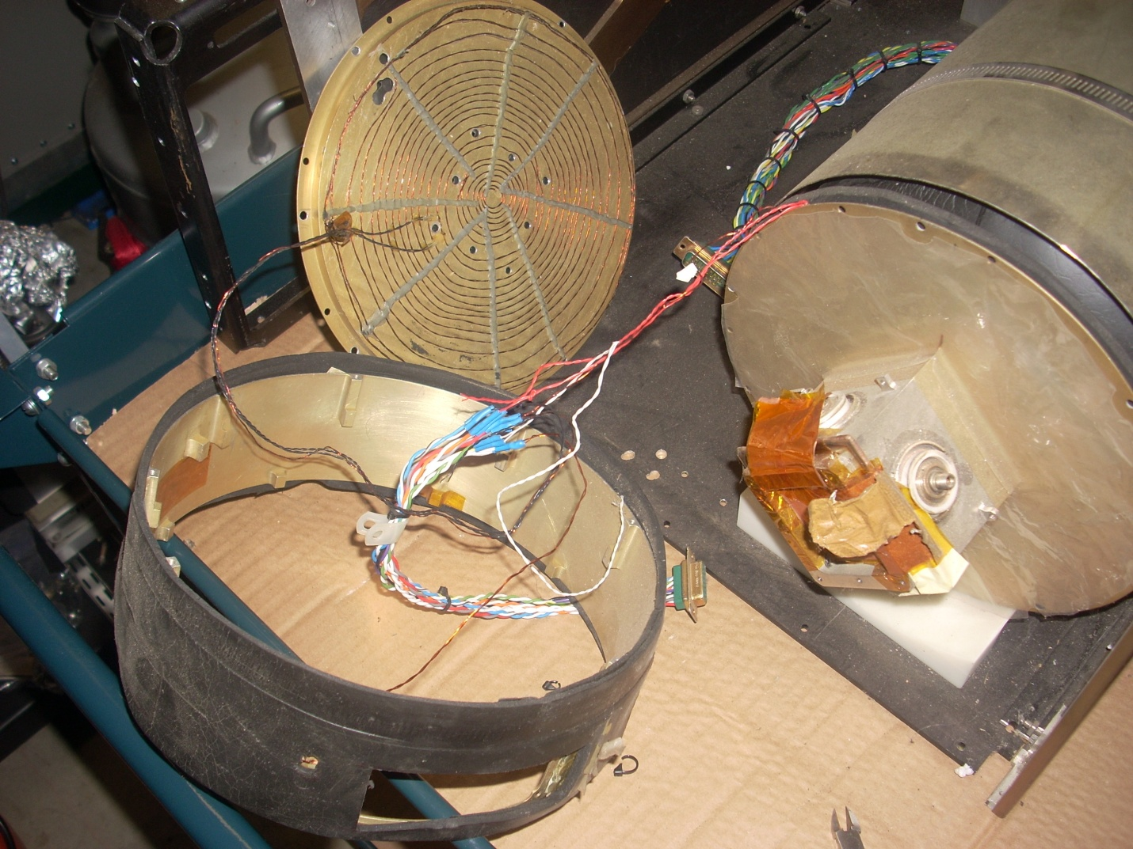
RF end of maser cavity assembly. (Shows the RF enclosure oven windings and the SMA cavity connections, RFin RFout Varactor.
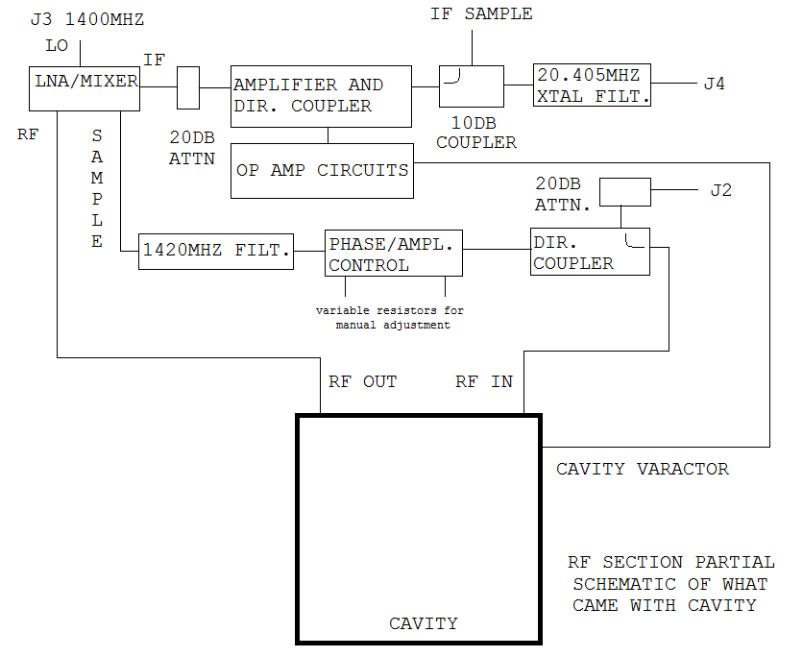

Looks like it was designed to provide extra gain and feedback at 1420.405 Mhz and thus provide a CW output???
Top section to provide a 20.405Mhz IF to the remainder of the RF section that will lock the reference oscillator.
Op Amp circuits to monitor the amplitude variations of the IF (caused by modulating the varactor?) and correct the varactor voltage to maintain the cavity tuning.
Bottom section to take a sample of the amplified 1420.405 Mhz, apply it to the cavity input, and by adjusting the phase and amplitude (via two pots) to achieve CW oscillation of the Maser.

Dissociator end of maser cavity assembly.

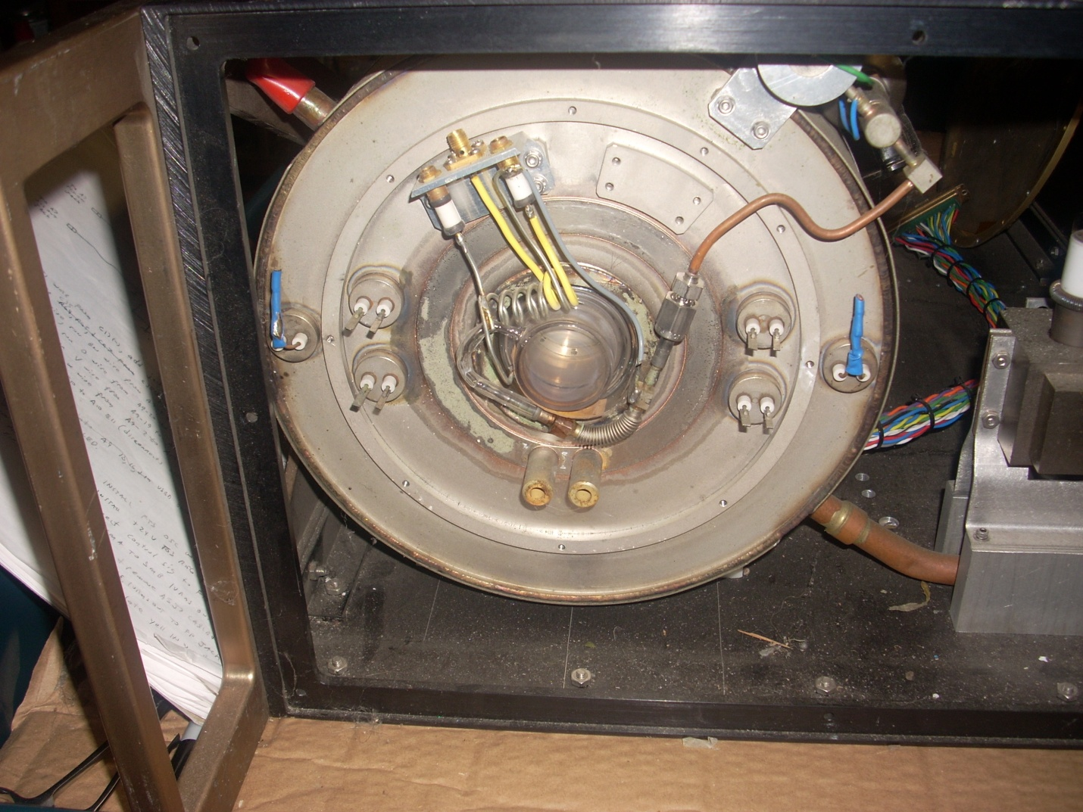
Hooking up an ion pump supply to the diode ion pump showed that it retained a good vacuum inside! The Hydrogen supply looks to be a Hydride based design with a heater voltage used to adjust Hydrogen flow. At this point the project languished due to lack of any documentation. Eventually the unit was moved onto a roll around card and I decided to work on determining the wiring connections to the ovens and C-field coil.
Carefully removing the outer magnetic shielding and the insulation around the outer oven I was able to determine the outer oven winding and thermistor connections and the C-Field connections. Note the Hi-tech Duct tape they used to hold the winding!
The outer oven winding impedance turned out to be 3.9 Ohms with a thermistor reading of 59K at ambient.
The wiring from the internal oven was now accessible but the windings themselves were hidden. I set up a DVM to monitor each of five thermistors while heating the oven windings one at a time with a 6 Volt lantern battery. In this was I was able to match the thermistors to their proper oven winding.
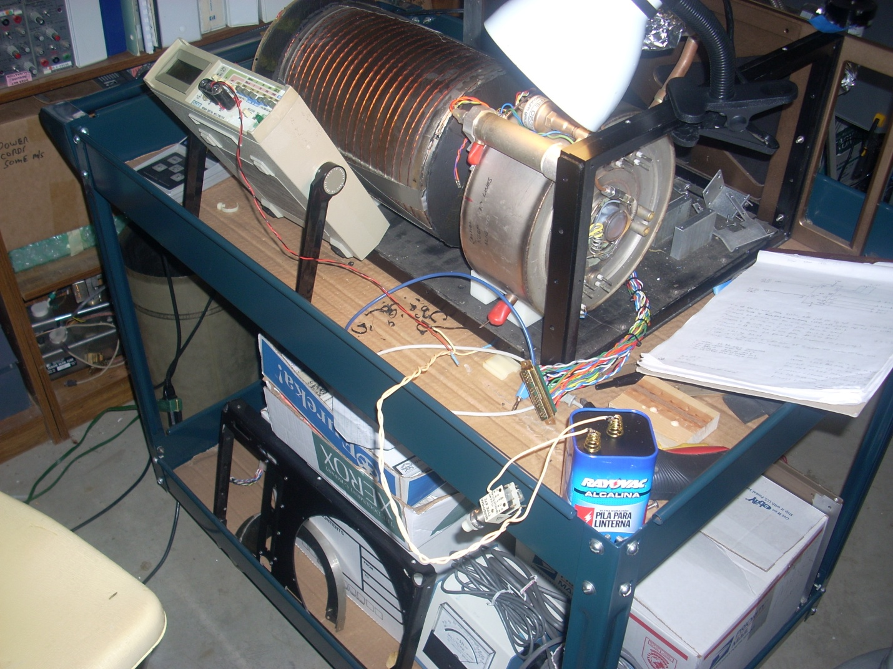
Finding the windings! You can see the external oven winding wrapped around the casing.
Next came applying +15VDC to the outer oven winding while monitoring the thermistor value and temperature (with an added thermocouple and meter) to determine the thermistor value at +45 Degrees C. (Picked as a likely outer oven temperature)
After about 2 ½ hours I was able to log the information. The thermistor is at about 18.5 to 18.8K at 46 Degrees C.
The 5 inner ovens impedances were between 2.8 and 3.9 Ohms.

Now I need to cobble together 5 simple controllers for the inner ovens so that I can determine their proper setpoint.
I’ll do this by setting the cavity varactor to the midpoint voltage and then measure the cavity frequency as the temperature increases.
Once the cavity is on frequency then the oven temperatures will be correct. I’ll then design a more precise controller for the cavity oven.
Heating the 5 inner ovens one at a time revealed one with a very long time constant, two with medium constants, and two with short time constants. The cavity, two end ovens, and two support ovens???

Here is a description of the units design so far.
SMA RF in and SMA RF out jacks from cavity including an SMA for the varactor.
Hydrogen supply via Hydride canister, regulated via a solid state pressure sensor and monitored via a TC gage tube.
SMA input to Dissociator coil assembly.
6 internal (Zirconium based?) getters to provide the bulk of the pumping and a small diode vacion pump for the remainder.
Two sets of water cooling connections used while activating the getters. Not needed now.
Unit has a neck coil but this is not normally needed for regular operation.
Cavity Q of around 7100.
Looks to have been built as a prototype in around 1985 based on component date codes. There are NO identifying marks as to who built it, and no documentation. It appears very similar to H. Wang’s “subcompact Q-enhanced active maser” Made for Hughes Research Labs. Any help in this would be appreciated! Especially a data sheet for a Foxboro 0-25S pressure sensor IC.
Some questions still needing answers:
>What C-Field current is required? (coil measures 4.5 Ohms and 254uH)
>What H2 pressure do I shoot for?
>Stay with the oscillation scheme or use a more conventional scheme that interrogates the Hydrogen line without adding gain?
More will follow after I get the inner ovens operating.
Then the plan is to see if I can get some hydrogen flowing, the Dissociator lit, and then see if any Maser action is discernable by monitoring the cavity ringdown time.

Not sure what to title this, maybe:
Passive Maser reverse engineering?
After market for Hydrogen Masers?
Garage based Hydrogen Masers?
Care and feeding of 2nd hand Masers?

