E1938A Pinout Pictorial
Rick Karlquist, Dec. 10, 2004

Introduction

The E1938A oven crystal oscillator controller board has various configurations for its D-subminiature connector. All configurations use
the same PC board with the same physical pin locations, however the
connector may be installed on either side of the board, and there are
various numbering schemes. This pictorial document shows where various signals on physically located in a photo, to avoid ambiguity with connector pin numbering schemes. Pin numbers in this document are the same as on the schematic.

Component side of board

See figure 1:

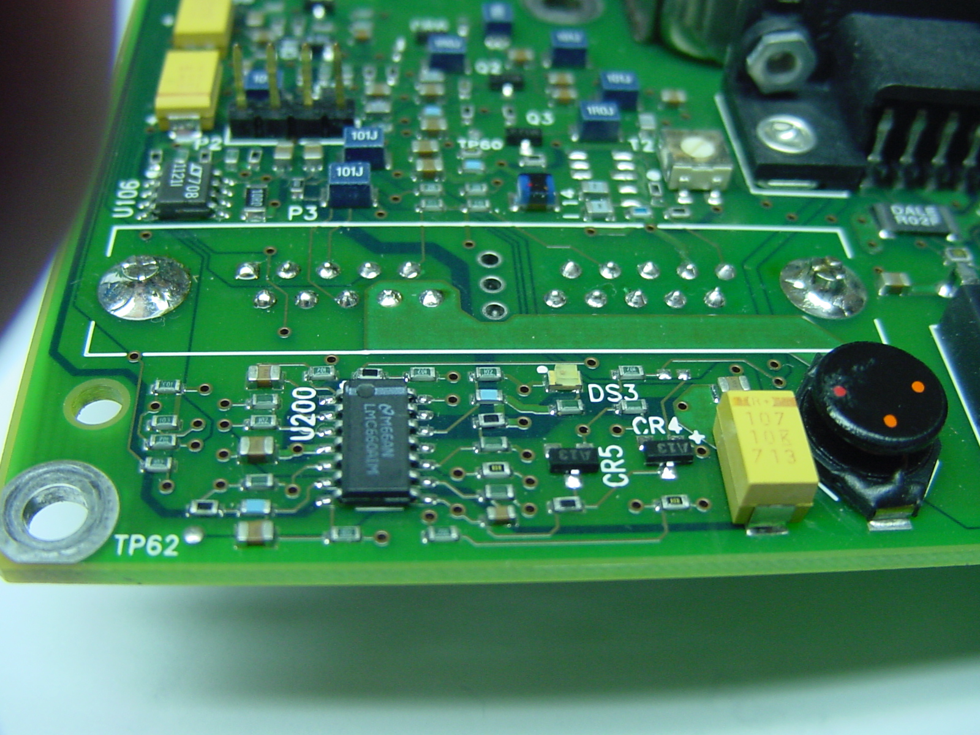
1. ACOM/DCOM
2. Vref Common
3. EFC shield
4. TX, serial port
5. Data from PIC
7. PIC data ready
6. Data to PIC
8. Vref, +2.5V
9. 10 MHz, common
10. 10 MHz, signal common
11. ACOM/DCOM
12. ACOM/DCOM
13. EFC+
14. +5V
15. +5V
16. RX, serial port
17. +12V
18. PIC clock
19. Not used
20. Not used
Figure 1. Component side of E1938A controller board.
Circuit side of board

Note that pin numbers are embossed on this connector. See figure 2:
5. Data from PIC
7. PIC data ready
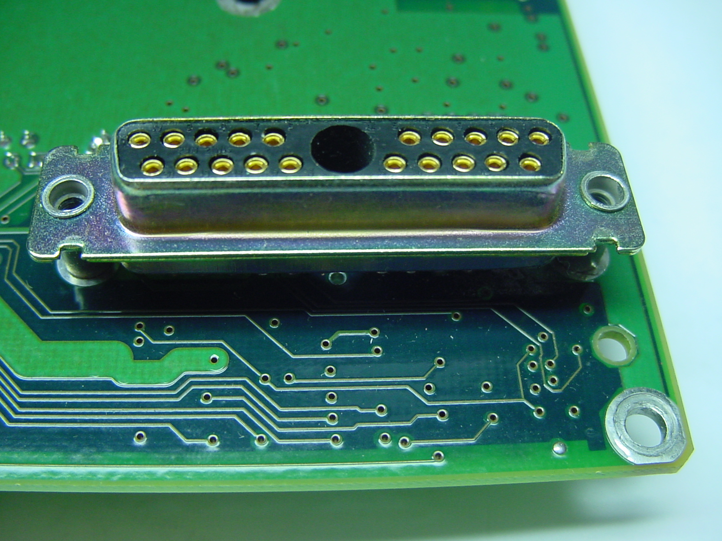
1. ACOM/DCOM
2. Vref Common
3. EFC shield
4. TX, serial port
6. Data to PIC
8. Vref, +2.5V
9. 10 MHz, common
10. 10 MHz, signal common
11. ACOM/DCOM
12. ACOM/DCOM
13. EFC+
14. +5V
15. +5V
16. RX, serial port
17. +12V
18. PIC clock
19. Not used
20. Not used
Figure 2. D-sub with coax insert on circuit side of PCB.

